JCP Digest Issue number 78 (2020:6)

Summarised from Journal of Clinical Periodontology Volume 47, issue 6 (June 2020), 768-776

Rapporteurs: Naz Kurt, Merve Bacgeroglu, and Deniz Findik Balci, with Hare Gursoy and Bahar Eren Kuru

Affiliation: Postgraduate programme in periodontology, Yeditepe University of Istanbul, Turkey

Study: To regenerate or to extract? 10-year results

Authors: Pierpaolo Cortellini, Gabrielle Stalpers, Aniello Mollo, Maurizio S. Tonetti
Background:
In patients with stage III and IV periodontitis, periodontal regenerative treatment can be used to improve long‐term clinical outcomes of severely compromised teeth with deep vertical intrabony lesions. Regenerative therapy has the potential to change the prognosis of periodontally hopeless teeth.
According to this study’s previously reported five-year follow-up results, high attachment-level gains can be obtained in periodontally hopeless teeth through regenerative treatment.
Periodontal regeneration can be a suitable alternative to tooth extraction and replacement with either implants or tooth-supported prostheses in teeth compromised by extremely severe attachment loss up to or beyond the apex.
Regenerative therapy’s prognosis and stability on severely compromised teeth and its cost-effectiveness are unclear compared with extraction and tooth replacement.
There is no evidence about the mean cumulative cost of recurrences and the total cost of treatment when regeneration of hopeless teeth is compared with their replacement.
Aim:
This study aimed to compare regenerative treatment with extraction and tooth replacement in cases of teeth with hopeless periodontal prognosis in terms of clinical, patient-centred, and economic outcomes over a 10-year period. The potential of regeneration for changing the prognosis of hopeless teeth was also evaluated.

Material & methods:

This 10-year randomised controlled clinical study started in 1998, including
50 subjects with stage III or stage IV periodontitis. Periodontal regeneration of hopeless teeth was compared with extraction and replacement. Subjects were randomly assigned to either the test group (periodontal regeneration) or the control group (extraction and replacement of hopeless tooth).

Patients in the test group were treated by periodontal regenerative microsurgery including papilla-preservation flaps and the application of regenerative material. In the control group, teeth were extracted and replaced with either implants or tooth-supported fixed prostheses.

All patients were placed in a supportive periodontal care programme with recall intervals every three months and yearly examinations. Recurrence and survival analyses were performed.

The primary outcome was the retention of teeth or teeth replacements. Secondary outcomes were periodontal parameters, technical or biological complications at periodontally treated teeth or at abutments of tooth or implant-supported bridges, and health-economic measures.

Patient-reported outcomes were based on patient preference regarding the treatment of compromised teeth. The evaluation was done using the OHIP-14 (Oral Health Impact Profile-14) questionnaire.

Results:

- 10-year survival rate of regenerated teeth was 88% and implant or tooth-supported fixed prostheses had a survival rate of 100%. Complication-free survival time was a minimum of 6.7 years for the test group and of 7.3 years for the control group, with a confidence interval of 95%. No statistically significant differences were detected between the groups.

- Recurrence analysis was used to quantify the cost over time and to enable the presentation of plural events related to the same subject and thereby avoid bias.

- Over the 10-year period, the total cost of treatment for the test group was considerably lower than that for the control group. Regenerative treatment had a higher initial cost, but extraction and replacement cost more in the following years.

- In the test group, the residual probing pocket depth (PPD) averaged 3.4mm ± 0.8mm and the clinical attachment level (CAL) gain 7.3mm ± 2.3.mm. At one-, five-, and 10-year follow-ups there were no differences regarding CAL gain or residual PPD compared with one year post-operation. This indicated that the stability was good in successful cases.

- One year after treatment, there were improvements for both groups in terms of patient-reported outcomes compared with their OHIP-14 scores at baseline. The level of improvement was higher for the regeneration group. Treatment satisfaction was high in both groups. A significant decrease regarding patient concerns about masticatory function and aesthetics was reported one year after treatment and these results were maintained through the 10-year follow-up period.

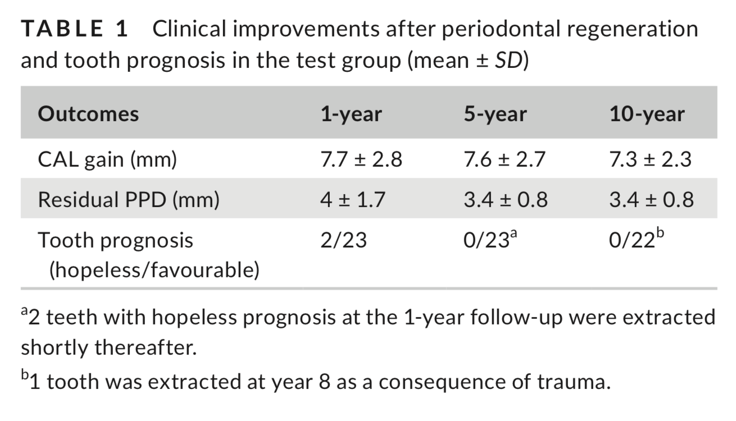
Limitations:
- The test group’s OHIP-14 questionnaire score improvements were unexpectedly good, and the results need to be confirmed.
- There might be a variation between the groups in terms of systemic diseases, genetics (the effect of the familial tendency for periodontal disease), and environmental and lifestyle factors.
- All cases in this study were characterised by the presence of good peaks of attachment/bone on the neighbouring teeth. Therefore, the outcomes cannot be generalised to cases without this specific morphology.
- Additional studies must be performed by different clinicians on intrabony defects with this level of severity to confirm the data.
Conclusions & impact:
- Periodontal regeneration is a clinically suitable and less costly alternative to tooth extraction and prosthetic rehabilitation for teeth compromised by extremely severe attachment loss up to or beyond the apex.
- Regenerative periodontal therapy improves the prognosis of hopeless teeth and preserves compromised teeth for the long term, with clinically stable periodontal parameters.
- Both regeneration and replacement treatments improve oral-health-related quality of life and reduce patient concerns.
- Although regenerative treatment has many previously proven benefits, its extensive application in the most difficult cases may be restricted because of the complexity of therapy and the importance of case selection.
- The recurrence analysis used in this study can be a useful tool for future studies.
- When treating stage III and IV periodontitis patients, periodontal regeneration can be the first choice of treatment for severe cases where the teeth are compromised by deep intrabony defects, as the regenerative approach has economic advantages and patients are likely to prefer tooth retention to extraction and prosthetic rehabilitation.

JCP Digest 78, published in October 2020, is a summary of the article ‘Promising long-term implant survival of TSFE without graft in reduced residual bone heights.’ J Clin Periodontol. 2020; 47 (6), 768-776. DOI: 10.1111/jcpe.13289

https://www.onlinelibrary.wiley.com/doi/10.1111/jcpe.13289

